Karst and Caves of the South Pacific

: A state-of-knowledge review

Elery Hamilton-Smith,

IUCN / WCPA Task Force on Caves and Karst.

V 1.1

July 2007

.

Contents

Introduction 2

Fiji 5

New Caledonia 10

Niue 14

Pitcairn 17

Rarotonga and Cook 24

Samoa 26

Solomon Islands 29

Tahiti and French Polynesia 37

Tonga 38

Vanuatu 43

Note: The Micronesian Islands are dealt with in a separate review

The editor is well aware that this document does not include significant information over the last 2-3 years. Updates and corrections will be welcomed and included in an updated version.

Introduction

Pacific Islands may be:

- Of continental character, e.g., New Caledonia
- Volcanic, often with fringing reefs of coralline limestone which may be karstic in character
- Atolls, comprised of coralline limestone, commonly based upon submerged volcanic islands.

In the strict sense, an atoll is a circular or irregular island surrounding a central lagoon. It originated as a fringing reef surrounding a volcanic island, then as the sea level dropped, so the volcanic island was submerged. The atoll is commonly karstified, and as an example, see the map of Ouvea (Loyalty Islands) below.

However, in due course, the central lagoon may become filled with broken limestone and soil and is then more properly referred to as coral island. The raised edge often remains, and the World Heritage Henderson Island is an excellent example of this stage of development.

Then in the Pacific region, tectonic change may cause the seabed (and the volcanoes upon it) to rise, and so an atoll may achieve a significantly high level above the ocean. When this occurs the characteristic atoll landform may even be disguised by tectonic change. Niue is a significant example of this.

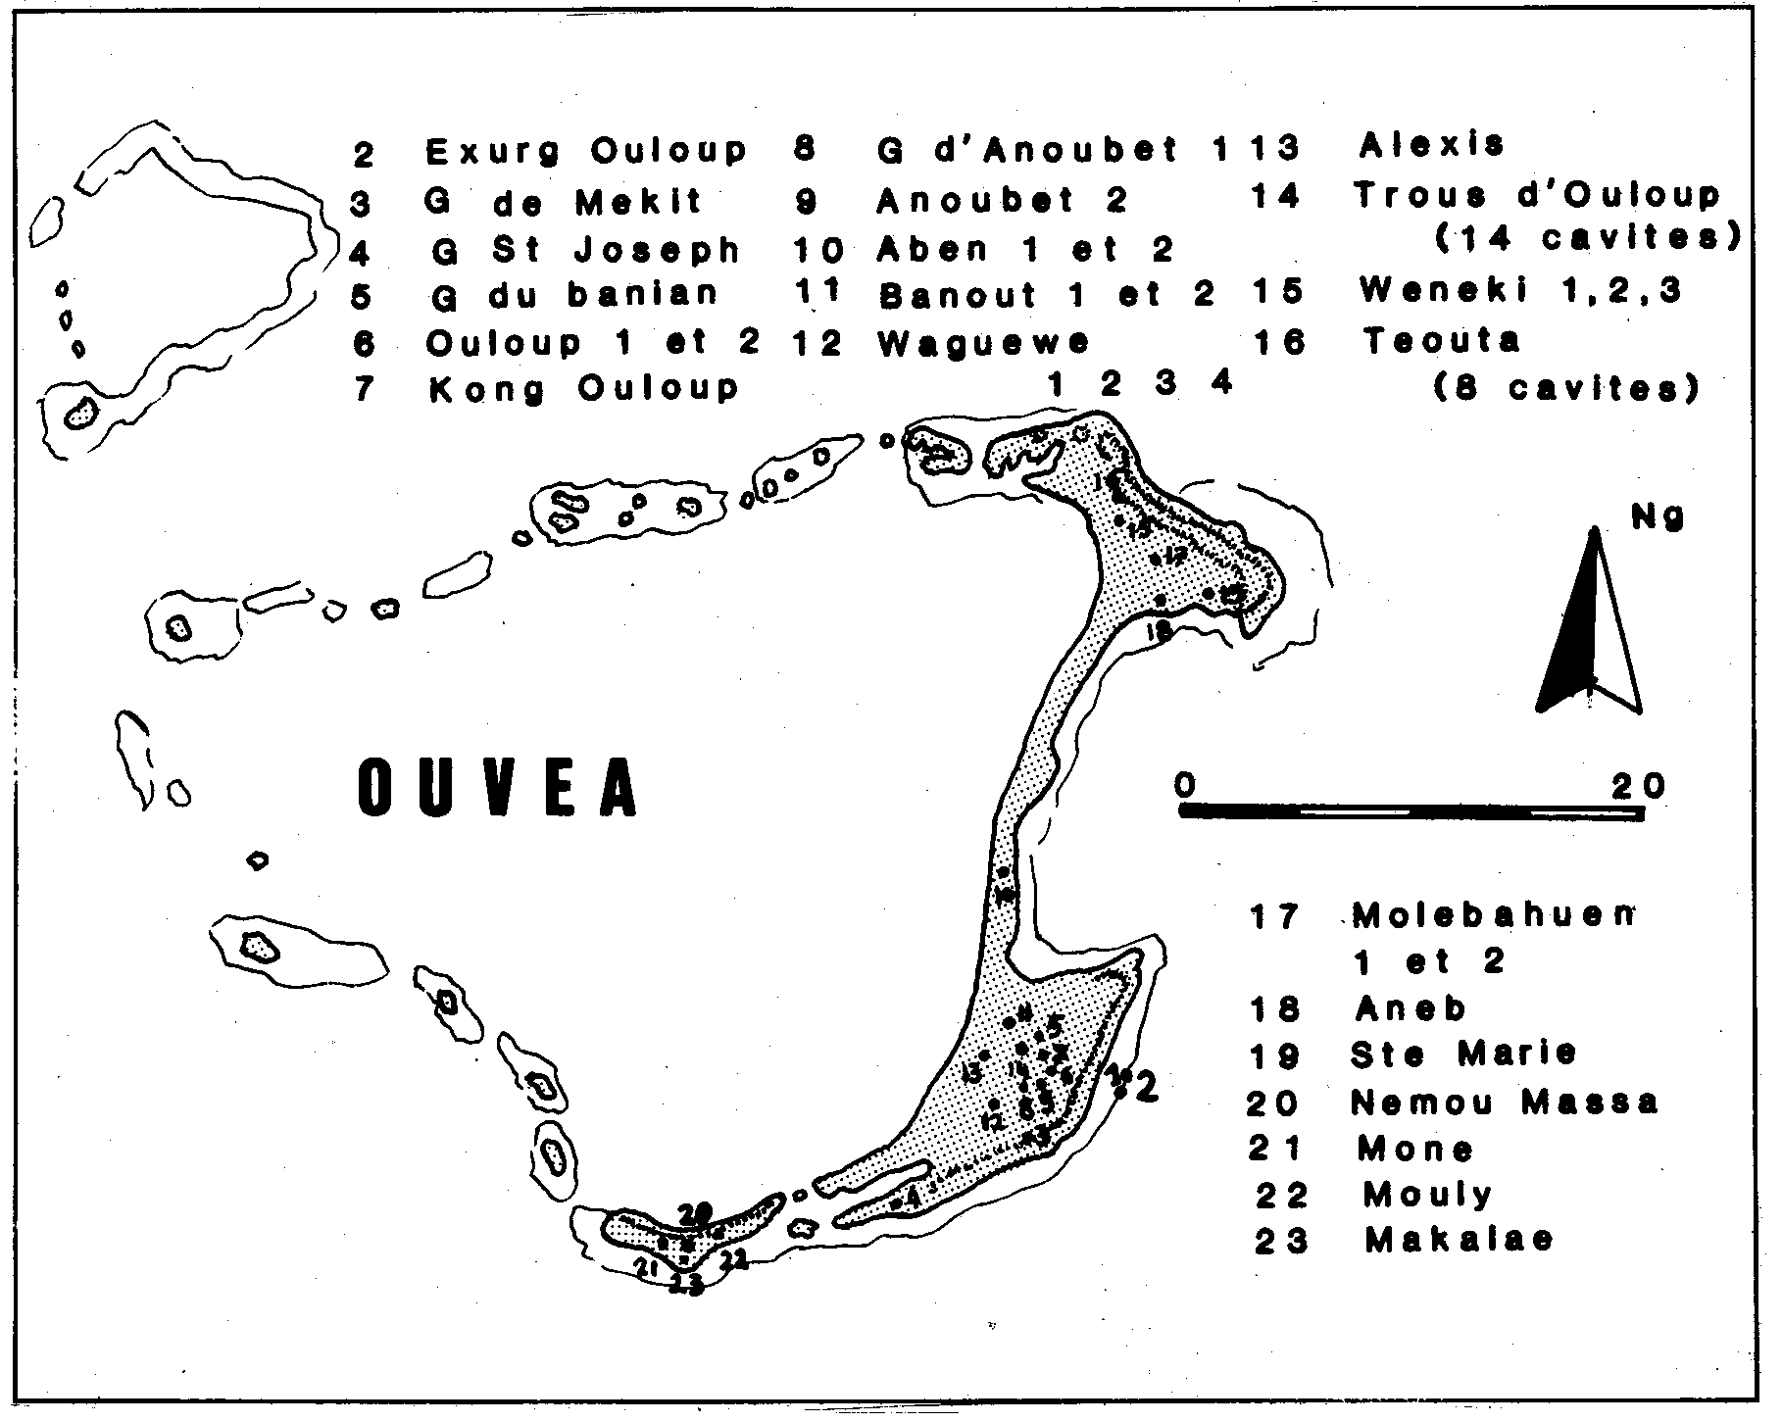
(from Thomas, C., 1987. Grottes de Nouvelle Caledonie, Centre Voyages, Noumea)

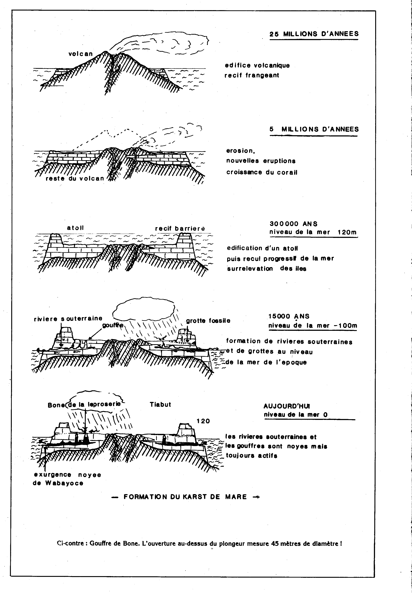
(from Thomas, C., 1987. Grottes de Nouvelle Caledonie, Centre Voyages, Noumea)

What follows deals with each nation in alphabetical sequence. However, there appears to be little karst or caves in Kiribati, Marshall Islands, American Samoa, Tokelau, Tuvalu, or Wallis and Futuna. Then although Nauru has extensive karren exposed by mining of the guano deposits, there is little in the way of natural features left. So, these countries are omitted below.

The need for review and development of protected area status or even international recognition through further World Heritage inscription was recorded at the 2001 Mulu Forum on Karst sites of the Asia-Pacific Region. This document is one step in that process.

Two sites have already been recognised on the World Heritage Register: Henderson Island and East Rennell. Little is known of the current state of conservation of either, although Henderson has suffered from frequent informal visiting by yachtsmen and timber harvesting for the craft industry of Pitcairn. There is no on-site management.

It must be recognised on one hand that the culture of the Pacific nations has given very considerable recognition to principles of conservation in resource management, but on the other hand, modernisation and tourism bring a new series of threatening processes to the region.

References of Pacific-wide relevance include:

Cole et al, (2000). South Pacific. Lonely Planet Guidebooks, Melbourne.

Inder, S. (ed.) (1978). Pacific Islands Yearbook. Pacific Publications, Sydney.
Juberthie, C & Decu, V. (eds) (1996). Encyclopaedia Biospelologica: Vol III. Sociètè Internationale de Biospèologie, Moulis, France.

Similarly, papers on bats often deal with the region as a whole:

Flannery, T. (1995). Mammals of the South-West Pacific and Moluccan Islands. Cornell University Press, New York.
Hutson, A.M., Mickleburgh, S.P. & Racey, P.A. (comp.) (2001) Microchiropteran Bats: global status survey and conservation action plan. IUCN/SSC Chiroptera Specialist Group, IUCN, Gland, Switzerland and Cambridge, UK.

Bibliographic Resources include:

Bourke, R.M. (1987) An annotated speleological bibliography of Oceania. Helictite 25(1): 3-20.

Bulletin Bibliographique Spéléologique, published by the Swiss Speleological Society. Files for 1988-2004 are currently available as hard copy and on Searchable CD-Rom. Future issues will appear in these formats.

The Pioneers of Island Melanesia Project is currently in process and may well seek evidence of early settlement on karst because of the occurrence of cave deposits. See http://www.eastpapuan.ling.su.se/index.html?Pioneers-intro.html for details and progress reports.

Fiji

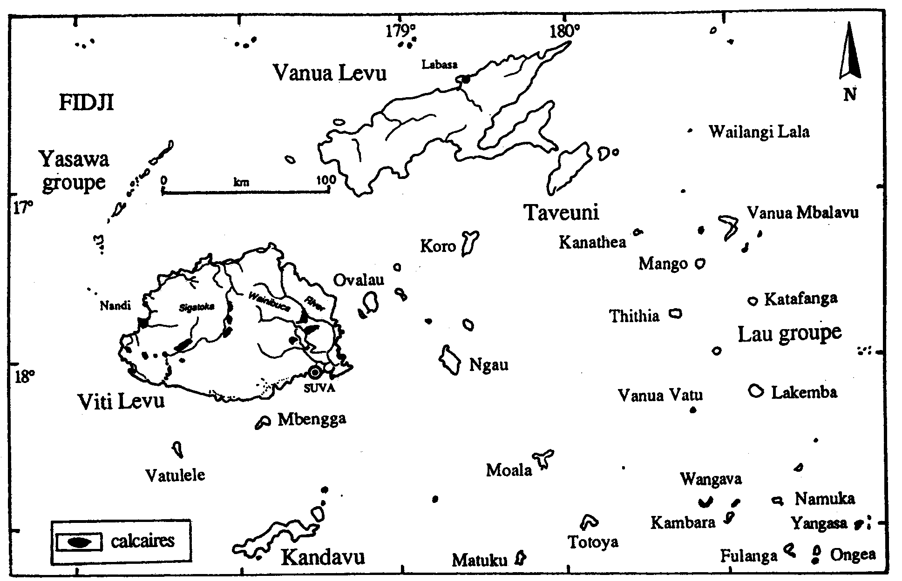

Map from Juberthie & Strinati 1996.

Overview

Fiji comprises both volcanic rocks and limestone. Virtually all the caves are in the limestone, although there are a few small lava tubes. Many are apparently of palaeontological or archaeological interest, and many studies can be found in the literature. Fortification of caves is also widespread.

Viti Levu

- Suva and surrounding areas:
A number of small caves, one of which (Kelabo) is inhabited by both swiftlets and bats and is the type locality of the bat Notopteris macdonaldi. Others include Nakorowaiwai, Nasau, Quaia, Nauluvatu, Waiqanake and Dharam Singh.

- Wainibuka
A small group of caves, of which Wailotua has been mined for guano and is also a show cave. This cave also houses both bats and swiftlets. Strinati and Aellen (1983: 5-16) suggest it is the largest in Fiji. Gilbert (2002) provides both excellent maps and descriptions.

- Sigatoka Valley:
Rodda (1966) distinguishes five separate areas of karst. Both he and Sawyer and Andrews (1907) provide relatively detailed descriptions. Watling & Pernetta (1977) provide an excellent and detailed description of the caves, including two burial caves, another which was fortified and obviously used as a dwelling place and another smaller cave which also had considerable evidence of human habitation. Volivoli Cave, immediately to the SW of Sigatoka has proved to be a valuable fossil site.
Hamilton-Smith briefly visited Sigatoka in 1977.

- Saweni
This cave was long utilised by humans, and was apparently used as a workshop for making shell ornaments. There are also burial sites within the cave. It is also rich in fauna (Gilbert 2002)

There are a number of other caves in the limestones between Sigatoka and Natadola.

- Yasawa

Gilbert (2002) briefly refers to a large cave on Yasawa that contains wall paintings.

Taveuni

Taveuni has been subject to relatively recent volcanism, probably as recent as 2,000 years ago. There are a number of Lava Tubes, of which Salialevu is probably the best known, but others include Waimagere, Soqulu, Qarawalu and Tubakau. Entry to Qara Tabu is forbidden under a long standing Tabu.

Lakeba

A large cave near the village of Nasaqalau is said to have been the first visited and explored by Europeans.

Yanuca

A burial cave is recorded here.

Vatulele

This island is noted for its various archaeological sites, but also for the occurrence of the well-known sacred red prawns, further discussed below.

The Lau Group

These islands are rich in large and often spectacular caves, some of which (at least on Namuka) house the famous scarlet prawns of Fiji and a number of which have ancient fortifications and other stone structures.

Islands identified in the literature as having caves include:

Bai Vatu
Cicia (Sawyer & Andrews 1907)
Fulaga (Ladd & Hoffmeister 1945)
Katafaga (Ladd & Hoffmeister 1945)
Laveba (Lakemba) (Nunn et al 1991)
Mago (Gilbert 2002)
Naitauba
Namuka-I-Lau (Ladd & Hoffmeister, Nunn et al)
Nayau (Nunn et al 1991)
Nghillinghillah
Quilaquila (Vanua Balavu) (Sawyer & Andrews 1907)
Thithia
Tuvuca (Rodda 1966)
Vanuavatu (Sawyer & Andrews 1907)
Waqava (Edmondson 1935; Ladd & Hoffmeister 1945)
Yagasa (Sawyer & Andrews 1907)

Cave-dwelling Fauna

The scarlet prawns as depicted on the special postage stamps issued to mark the beginning of the millennium. | 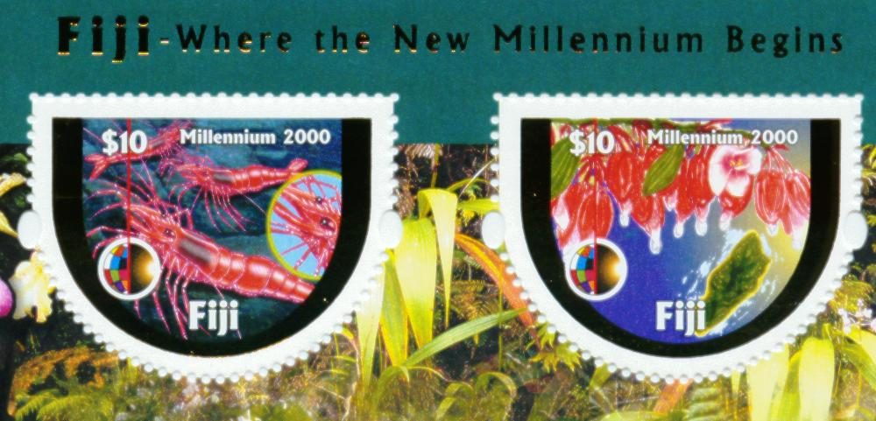

The following summary is taken from Jones & Pinheiro (1997) Fiji, Lonely Planet Guidebooks, Melbourne, p. 172. It is reproduced in full as it no longer appears in the current edition.

Sacred Red Prawns

Near the north end of Vatulele the limestone is honeycombed with caves and pools which, despite being inland from the shore, are affected by tidal movements. These pools are the habitat of the famous red prawns, or ura bata, meaning cooked prawns. The islanders who won’t eat or harm them regard the red prawns with great respect. They believe that anyone who takes the prawns will be shipwrecked when they sail away from the island. The prawns are known to respond when called by traditional magic chants and there is a local legend to explain their origin.

There was once a beautiful but cold-hearted young woman called Yalewa, who treated her many suitors with disdain, preferring to play with her friends. She told her chiefly father that she would only accept a man who was brave and creative with godly powers and would never marry anyone who came to the island by mere canoe. One day an ingenious and hopeful young chief arrived from across the sea on a string of stepping stones, bringing with him a basket of cooked prawns as a present. Yalewa angrily and ungraciously struck him with the basket, scattering its contents. The prawns came alive and can be found in the pools of Vatulele to this day. The frightened suitor fled home across the stepping-stones and never returned.

There appear to be only two cave-dwelling bats: the long-tailed blossom bat, Notopteris macdonaldi and the mastiff bat, Chaerephon bregullae. However, the endangered Emballonura semicaudata often roosts in caves, usually near the entrance. Juberthie & Decu (1996), provide a comprehensive summary of the little that is known of the invertebrate cave fauna with virtually all records coming from Wailotua.

Palaentology

Significant fossil sites have been reported from Sigatoka, Tau (SW of Sigatoka), Udit and Wainibuka (near Suva). These include a number of giant extinct species of both birds and reptiles. (Worthy, 2001a, 2001b, Molnar et al, 2002, Anderson et al, 2001.)

Conclusion

The prima facie evidence points to the Lau caves as being most worthy of more comprehensive assessment. The archaeological sites, the biodiversity and the cultural traditions associated with the scarlet prawn together justify this. A group of the important localities of Vitu Levu might also be brought together and assessed as a serial or cluster site. Such an assessment may provide evidence to justify international recognition of both.

References

Anderson, A., L.K. Ayliffe, D. Questiaux, N. Spooner & T. Worthy. (2001) The terminal age of the Fiji megafauna, in Histories of Old Ages: essays in honour of Rhys Jones. Pandanus Books, RSPAS, Australian National University, Canberra.

Best, S.B. (1984). Lakeba: the prehistory of a Fijian island. Unpublished PhD thesis, Auckland University.

Cole et al., (2003) South Pacific. Lonely Planet Guidebooks, Melbourne. p. 162

Derrick, R. A. (1965). The Fiji Islands: A Geographical Handbook. Government of Fiji, Suva. pp. 54, 222, 308, 313

Derrick R.A. (edited posthumously) (1978). Some Fijian caves. The British Caver, 69: 23-25.

Edmonson, C. H. (1935) Atyidae of Southern Polynesia. Occasional Papers of the British Museum 11(3): 1-19.

Gifford, E. W. (1951). Archaeological Excavations in Fiji. Anthropological Record, 13, 3, pp. 1-288 (University of California Press).

Gilbert, T., (posthumous, 1984) Limestone and volcanic caves of the Fiji Islands. Cave Science, 11: 105-118.

Juberthie, C. & Strinati, P. (1996) Iles Fidji, in Juberthie, C & Decu, V. (eds) (1996). Encyclopaedia Biospelologica: Vol III. Sociètè Internationale de Biospèologie, Moulis, France, pp. 2109-2114.

Ladd, H. S. & Hoffmeister, J. E. (1945) Geology of Lau, Fiji. Bishop Museum Bulletin 181.

Molnar, R.E., T.H. Worthy, & P.M.A. Willis. (2002) An extinct Pleistocene endemic mekosuchine crocodylian from Fiji. Journal of Vertebrate Paleontology, 22(3): 612-628.

Nunn, P.D., Ollier, C. & Rawaico, N.B. (1991). Caves of Eastern Fiji. Helictite, 29(2): 42-47.

Rodda, P., 1966. Unpublished review of Fiji Caves. In Hamilton-Smith files.

Sawyer, B. & Andrews, E. C. (1907) Notes on the Caves of Fiji with Special Reference to Lau. Proceedings Linnean Society of New South Wales, 26: 91-106.

Sanborn, C. C. (1931) Bats from Polynesia, Melanesia and Malaysia. Field Museum Publications, Zoological Series 18(9): 7-29.

Strinati, P. & Aellen, V. (1983) Voyage Biospeleologique autour du Monde. Memoires du Speleo-club de Paris, 9: 1-29.

Watling, D. & Pernetta, J.C. (1977). Limestone Caves in the Sigatoka Valley, Viti Levu, Fiji. Studies in Speleology, 3(2): 78-86.

Worthy, T.H. (2001a) A giant flightless pigeon gen. et sp. nov. and a new species of Ducula (Aves: Columbidae) from Quaternary deposits in Fiji. J. Royal Society of New Zealand, 31: 763-794.

Worthy, T.H. (2001b) A new species of Platymantis (Anura: Ranidae) from Quaternary deposits in Vitu Levu, Fiji. Paleontology, 44(4): 665-680.

New Caledonia

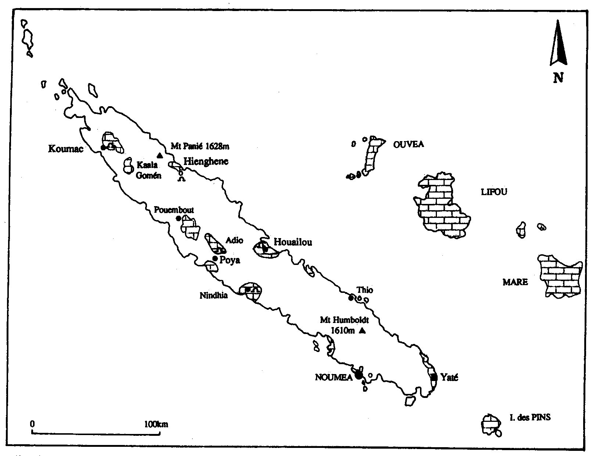
Map from Juberthie & Decu 1996.

Overview

New Caledonia comprises

The main island (Grande Terre) and offshore Isle of Pines, both of which are of a ‘continental’ character, and The Loyalty Islands - atoll of Ouvea and coral islands of Lifou and Mare

From a speleological perspective, it is one of the more thoroughly investigated and documented of the Oceanic nations. Similarly, general geology and zoology have been well examined.

The map above (Juberthie & Decu 1996: 2121) shows the distribution of limestone. On the Grande Terre, most investigation has taken place at Poya and Koumac, with some less intensive study of Hienghene, Nindhia, near Houailou, and Ouaoué, near Bourail.

Poya

Grotte d’Adio is a large and complex river cave which runs right through a large massif of limestone (Thomas 1987: 14-15). It is richly decorated with both normal calcite speleothems and large extruded gypsum crystals. It has a rich fauna with Miniopterus spp. and Notopteris neocaledonica bats and the swiftlet Collocalia spodiopygius. The guano in turn also provides for a mix of invertebrate species, including a large spectacular but undescribed Rhaphidophorid. This fauna is listed and briefly described in Juberthie & Decu (1996: 2126-2130).

There are various other caves in the area, but these are less well documented.

An interesting feature that does not appear to have been previously documented is the occurrence of series of parallel charcoal markings on the walls of the Grotte d’Adio. Apparently the Kanak population saw the journey right through the cave as a test of manly courage, and participants carried bundles of dried Niaouli (Melaleuca quinquenervia) branches that were ignited to provide illumination. To increase the level of illumination when required, they would whirl these above their head, then as the flame died down, the tip of the bundle would be brushed against the wall to knock off the dried charcoal residue left after burning of the oils. (Pers. Comm. Luc Chevalier, Director Noumea Museum).

Koumac

Again, the best-known cave is a large and spectacular river cave (Thomas 1987: 8-9) but other smaller caves also exist in the same massif, including at least one used as a burial site. There are also a number of large dolines, but generally these do not lead into caves. The main cave is subject to extreme flooding at intervals, and it is clear that a great deal of vadose corrosion occurs.

Hienghene

This is a coastal area with a series of limestone towers, several of which have medium size caverns within. The most spectacular is probably that known as the Tours de Notre-Dame which is actually in the sea but can be readily reached by wading or even walking at low tide. Harris et al (1976: 47-56) documented four of the caves.

This part of the coast is generally spectacular and photographs appear in tourism publicity (and on postage stamps).

Nindhia

The major cave at this site is one that can be entered from the base of a limestone outcrop and leads up to the summit of the area. It was seen as being of special importance as both a burial cave and a fortress. Entry by visitors is discouraged, but Harris et al (1976: 59) documented a smaller low-level cave.

Ouaoué

A relatively small joint-controlled cave exists here.
Isle of Pines

The central part of the Island is made up of peridotite, but is surrounded by coralline limestones. Thomas (1986: 50) identified a total of 10 caves. But Juberthie and Decu (1996: 2125) claim that 120 have been identified. Illiffe and Sarbu (1990) found these to have a relatively rich anchialine fauna. In particular, they reported on the Grotto de la Troisieme. Logan and Cole (1997: 213) describe two readily accessible dry caves one of which (Wèmwânyi) is of historical and cultural value as the hiding place a queen during tribal warfare in the mid 19th Century.

Loyalty Islands

Ouvéa has 43 identified caves, blue holes and related sites, of which the most spectacular is the Trou Bleu d’Aben, some 50 m. in diameter.

The members of the 1988 rebellion used one of the caves and the army killed seventeen of them in the cave.

Lifou has only 26 explored caves, but a number of these are relatively large and spectacular, especially to divers who are able to enter underwater caverns with rich decoration. Others above water level include caves (e.g., Wanaham) with rock art and burial sites.

Mare has thirteen recorded caves, some of which have not as yet been explored. Some are located in sense forest, and most demand equipment for vertical and often free-fall descent, and demand a high level of diving competence. The cave Bone de la Leproserie, for instance, has an entrance 25m. in diameter, but visitors must then descend to a lake 160m. in diameter – one of the largest such lakes in the world.

Cave-dwelling Bats

There are a number of mis-identifications in the literature. Flannery (1995) lists
Miniopterus australis, M. macrocneme, M. robustior and Notopteris neocaledonica.

References

Flannery, T. 1995. Mammals of the South-West Pacific and Moluccan Islands. Cornell University Press, New York.

Harris, S., Gillieson, D., Gleeson, L.P. & Landsberg, J. 1976. Caves of New Caledonia: Report of the 1975 Australian Expedition. Published by the editors. 68pp.

Hayllar, T., Andrews, W. & Hawken, A. 1965. New Caledonia – Exploration. SSS Communications, 1: 8-16.

Illiffe, T. & Sarbu, S., 1989. Anchialine Caves and Cave Fauna of the South Pacific. NSS Bulletin, 48(4): 88-96.

Juberthie, C. & Decu, V. 1996. Nouvelle-Calédonie. In Juberthie, C & Decu, V. (eds) (1996). Encyclopaedia Biospelologica: Vol III. Sociètè Internationale de Biospèologie, Moulis, France. Pp. 2121-2131.

Logan, L. & Cole, G. 1997. New Caledonia. Lonely Planet Guidebooks, Melbourne.

Thomas, C. 1987. Grottes de Nouvelle-Calédonie. Centre Voyages, Noumea. 52pp.

Niue

Niue is a single island, formed by the gradual rise over the last 500,000 years of a submarine volcano with a surrounding coralline atoll It has a variety of landforms, including many chasms cut in the rock, many of which are associated with caves. Terry & Nunn (2003) provide the most recent and thorough account of the geomorphology of the island.

Niue is one of the largest uplifted atolls, with an area of 259 square kilometres, and 68m of limestone exposed above sea level, with a further c.500 m below water. Still-stands of changing sea levels are displayed by a series of marine terraces at various heights. The former atoll provides a raised rim some 70m in height, while the former central lagoon is now a depression of some 35m below the coastal rim. It has been filled with cemented calcareous sand much of which has been dolomitised. Its origin is probably based in both its original atoll structure and some lowering that has resulted from karstic solution of unconsolidated sands.

The island receives an average of some 2050mm of rainfall and this maintains an extensive freshwater lens that extends in places to well over 100 m below sea level.

The various chasms which cut through the outer rim and one or more of the quaternary terraces are though to have originated as faults which were caused by tectonic movements during the uplift of the island. However, there are some ambiguities in the evidence, and research may yet elucidate their genesis and development more adequately. The many caves appear to have formed in the epiphreatic zone during various periods of still-stand, and hence occur at several levels. Speleothems are abundant although often badly damaged as a result of both natural causes and vandalism.

Illiffe (1996) provides a useful general description and notes the occurrence of a number of anchialine crustaceans. Cole et al. (2000) also list a number of caves, some of which are shown to visitors. As in many Pacific countries, the caves are a rich source of archaeological sites. Trotter (1979) recorded 100 such sites, if which 59 were in caves.

It is claimed that the Huvalu Forest Nature Reserve was established as a protected area by the first settlers when they arrived, probably over 1,000 years ago.

Named caves include:

Anapaluki
Anatoloa
Avaiki
Palaha
PWD
Talava
Ulupaka
Vaitanetane

Other named features include:

Anapala Chasm
Anatuku Chasm
Makato Chasm
Matapa Chasm
Paduo Chasm
Talava Arches
Togo Chasm
Vaihoko Chasm
Vaikona Chasm
Vaitoi Chasm

Conclusion

From a geomorphic perspective, Niue is probably the best-developed and most interesting raised atoll coral island. It thus encapsulates much evidence of the geoclimatic history of the Pacific and provides a rich source of evidence on island karst evolution. This is accompanied by the immense number of cultural heritage sites, including not only burial and other sites of archaeological value, but the Huvalu
Forest continues to support a rich biodiversity and should be recognised as one of the early protected areas.

References

Cole et al, (2000). South Pacific. Lonely Planet Guidebooks, Melbourne.

Crossley, P. 2003. The caves of Niue. NZ Speleological Bulletin 10 (193), 211-223.

Illiffe, T. 1996. Niue. in Juberthie, C & Decu, V. (eds) (1996). Encyclopaedia Biospelologica: Vol III. Sociètè Internationale de Biospèologie, Moulis, France, pp. 2199-2201..

Steadman, D. W., Worthy, T. H., Anderson, A. J. and Water R., (2000). New species and records of birds from prehistoric sites on Niue, Southwest Pacific. Wilson Bulletin 112(2): 165-186.

Terry, J.P. and Nunn, P.D. (2003). Interpreting features of carbonate geomorphology on Niue Island, a raised coral atoll. /Zeitschrift fur Geomorphologie/ N.F., Suppl.-Vol. 131, 43-57.

Trotter, M.M. (1979) Niue Island Archaeological Survey. Canterbury Museum Bulletin: 7.

Walter, R.; Anderson, A. 2002. The Archaeology of Niue Island, West Polynesia. Bishop Museum Bulletin in Anthropology 10. 167 pp.

Williams, P.W. (1992). Karst hydrology, in M.P. Mosley (ed.) Waters of New Zealand. NZ Hydrological Society, Wellington, 187-206.

Worthy, T. H., Walter, R. and Anderson, A. J., 1998. Fossil and archaeological avifauna of Niue. Notornis 45: 177-190.

Pitcairn

Overview

The Pitcairn group consists of Pitcairn Island proper that is entirely made up of Volcanic Rock, several small atolls and the World Heritage Henderson Island. Although Christian’s Cave is a named site on Pitcairn, it is nothing more than a rock overhang. Henderson is a coralline island, although often referred to as an atoll. It was inscribed on the World Heritage list as the least damaged “atoll’, being “practically untouched by a human presence.”

In fact, there is a genuine problem here. The island has no on-site management. Although passing deep ocean yachts people are formally required to get a permit to land, many do land and camp without any permit. Pitcairn people also visit at intervals to harvest miro wood (Thespisea populnea) for commercial wood carving purposes. We are unaware of any environmental monitoring of either of these activities.

The official records of the UNESCO Office and the World Conservation Monitoring Centre are appended below.

Conclusion

An approved management plan should be put in place and steps taken to establish regular environmental monitoring as a matter of urgency.

References

Hepburn (1992) Henderson Island World Heritage Site: Draft Management Plan.
United Kingdom Foreign and Commonwealth Office.

Juberthie, C. (1996) Pitcairn, in Juberthie, C & Decu, V. (eds) (1996). Encyclopaedia Biospelologica: Vol III. Sociètè Internationale de Biospèologie, Moulis, France, pp. 2203-2204.

Winthrop, Mark, The Henderson Island Website. www.winthrop.dk.hender.html
Henderson Island
Pitcairn Island group
S24 22 E128 20

Date of Inscription: 1988
Criteria: N (iii) (iv)

Brief Description
Henderson Island, which lies in the eastern South Pacific, is one of the few atolls in the world whose ecology has been practically untouched by a human presence. Its isolated location provides the ideal context for studying the dynamics of insular evolution and natural selection. It is particularly notable for the 10 plants and four land birds that are endemic to the island.

Documents
- Report of the 12th Session of the Committee
- Advisory Body Evaluation

Links
- Natural site datasheet from WCMC
- The Henderson Island website

- http://whc.unesco.org/pg.cfm?cid=31&id_site=487

World Conservation Monitoring Centre

Protected Areas Programme
World Heritage Sites
COUNTRY United Kingdom - Pitcairn Islands
NAME Henderson Island
IUCN MANAGEMENT CATEGORY
Natual World Heritage Site - Criteria iii, iv
BIOGEOGRAPHICAL PROVINCE 5.04.13 (Southeastern Polynesian)
GEOGRAPHICAL LOCATION Henderson Island is the largest island in the Pitcairn Island group, one of the remotest groups of islands in the South Pacific, with no major landmass within a 5,000km radius. The group comprises four islands, with Henderson lying 200km east-north-east of Pitcairn, 200km east of Oeno and 360km west of Ducie. Only Ducie, and the Chilean islands of Rapa Nui (Easter Island) and Sala y Gomez lie further to the east within Polynesia. Approximately 24°22'S, 128°20'W
DATE AND HISTORY OF ESTABLISHMENT Henderson Island has not been declared a protected area as such, although it receives de facto protection from its isolation, and various restrictions on possession, occupation and transference of lands applied under the Lands and Administration of Estates Ordinance. Some wildlife protection is provided by part IV of the Local Government Regulations.
AREA Land area 3,700ha
LAND TENURE The Pitcairn Island group is a Dependent Territory of the United Kingdom, and Henderson is Crown Land.
ALTITUDE Up to a maximum of 33m
PHYSICAL FEATURES Henderson is an elevated coralline limestone ("makatea") island which rises as an isolated conical mound from a depth of about 3.5km, and is presumably a reef-capped volcano. The surface of the island is in large part reef-rubble interspersed with areas of dissected limestone, surrounded by steep limestone cliffs undercut on all sides except to the north. There are three main beaches, to the north, north-west and north-east. Tidal range at spring tides is probably about 1m, and tides are semidiurnal. The central depression is considered to be an uplifted lagoon. Freshwater is almost completely absent, only occurring as drippings in caves, and as a spring below high tide level in the north (flow and permanence unknown). The geology of the island is summarised by Fosberg et al. (1983), who conclude that the limestones are of late Tertiary age. It is also suggested that much of the inland topography may be karst features.
There is a fringing reef at least 200m wide to the north, north-west and north-east sides of the island, backed by a wide beach (St John and Philipson, 1962). Reefs off the north and north-east beaches are seawardly sloping reef platforms without reef crests, and are not typical fringing reefs. Coral cover is about 5%, dominated by Pocillopora with Millepora becoming dominant at depths greater than 7m (Paulay, 1987). Submassive Acropora colonies are also present on the buttresses and solid substratum (Richmond in litt., 1987). In total, 19 genera and 29 species of coral were collected in 1987 (Paulay, 1987). There are two narrow channels through the reef on the north and north-western coasts (Serpell et al., 1983).
CLIMATE Henderson lies in the south-east trades, and total recorded rainfall for the period from February 1991 to January 1992 was 1623mm. Average monthly maximum temperature, during the same period, ranged from 29.6°C (February) to 24.2°C (June); average monthly minimum temperature ranged from 22.2°C (February) to 15.7°C (June) (Brooke, 1992).
VEGETATION The vegetation of the island has not been modified to any significant extent, and most of the surface of the island is densely vegetated with tangled scrub and scrub forest 5m-10m tall. The central part of the depression is more sparsely covered. The flora is described by St John and Philipson (1962), Fosberg et al. (1983) and Flenley et al. (1987). The island has a high degree of endemicity for its size, out of a total of 51 native flowering plant taxa, ten are endemic. The tallest trees are screw-pine Pandanus tectorius, and other trees include the endemics Santalum hendersonense, Myrsine hoskae, Celtis paniculata var. viridis, and two endemic varieties of Bidens hendersonensis. The last named species, which is listed by IUCN as rare or possibly endangered, is of particular botanical interest as a woody member of a mainly herbaceous genus, and also because of its isolation from related genera within the Compositae. Hardwoods, miro Thespesia popuinea and toa Cordia subcordata also occur.
FAUNA Fauna recorded from the island are listed in Fosberg et al. (1983), and variously commented on by other visitors. There are no native species of land mammal. All four of the island's land birds are endemic, flightless Henderson rail Nesophylax ater, Stephen's lorikeet Vini stepheni (R), Henderson fruit dove Ptilinopus insularis, and Henderson warbler Acrocephalus vaughani taiti. Very little information is available on either the ecology or the status of these four birds. Fifteen seabirds have been recorded, at least nine of which are thought to breed on the island (Williams, 1960; Bourne and David, 1983); Murphy's petrel Pterodroma ultima, phoenix petrel P. alba, herald petrel P. arminjoniana, Kermadec petrel P. neglecta, shearwater Puffinus pacificus, masked booby Sula dactylatra, red-tailed tropicbird Phaethon rubicauda, brown noddy Anous stolida, blue-grey noddy Procelsterna caerulea, and fairy tern Gygis alba. Bourne and David (1983) provide a species list with detailed annotation. Other terrestrial species are also poorly recorded and understood (including lizards and skinks as well as invertebrates), and it is likely that the invertebrate fauna is much larger, including several more endemics. For example, a new species of hawk-moth was identified in 1986, which is significantly different from any described hawk-moth.
Various records of the marine and littoral fauna have been made by Paulay (1987), and by Broodbakker (in litt., 1981; 1987) and Richmond (in litt., 1987), and a list of marine molluscs recorded from Henderson is given in Fosberg et al. (1983). Species of particular note include coconut crab Birgus latro (R) (identified from remains collected in 1987), at least two coenobite species (one of which was found to be the commonest crustacean on theisland in 1987), and spiny lobster Panulirus penicillatus (CT). Green turtle Chelonia mydas (E) occasionally nests on the island (Fosberg et al., 1983). Collections of marine molluscs and sponges and of as yet unidentified caridean shrimps (mostly Alpheids, probably comprising 5-8 species), were made in 1987. There is a diverse echinoderm fauna. An unidentified holothurian is common on the northern reef flats, and an echinoid Heterocentrotus sp. (possibly H. trigonarius) is locally abundant on the sloping marginal reefs and shallow reef flat of the northern beach. Fish are sparse, with Caranx lugubris being the most common and obvious species. A more comprehensive account of the corals is given in UNEP/IUCN (1988).
CULTURAL HERITAGE The history of the island, which has been uninhabited apart from occasional visitors, is described in Fosberg et al. (1983). Recently discovered archaeological remains suggest that Henderson was colonised by Polynesians between the 12th and 15th centuries (Sinoto, 1983), but their impact would appear to have been slight, although there is some disagreement over this (Steadman and Olson, 1985; Bourne and David, 1986).
LOCAL HUMAN POPULATION The island is visited by Pitcairn islanders once or twice each year, chiefly to cut "miro" Thespesia populnea and tao from which carvings are made for sale to visitors to Pitcairn, and sandalwood Santalum hendersonense.
VISITORS AND VISITOR FACILITIES Cruise ships visit occasionally (M. de L. Brooke, pers. comm., 1990).
SCIENTIFIC RESEARCH AND FACILITIES Fosberg et al. (1983) summarise scientific expeditions to the island, of which the two most important were the Whitney South Sea Expedition in 1922 and the Mangarevan Expedition of 1934. They also summarise the published information, and provide nearly 100 references. The island was visited by Operation Raleigh in spring 1987 and by an expedition from the Smithsonian Institution in the same year, and by the Sir Peter Scott Commemorative Expedition in 1991-1992.
Henderson is the world's best remaining example of an elevated coral atoll ecosystem and is thought to be of outstanding value in this regard (Fosberg and Sachet, 1983). This is particularly so because of the relatively low level of disturbance in comparison with other raised coral atolls. The importance of the island was indicated by the International Biological Programme and by a resolution of the 15th Pacific Science Congress, as well as by individual scientists.
CONSERVATION VALUE Henderson remains in an undisturbed state, largely as a result of its remoteness, and its inhospitable nature. Unlike other oceanic islands, it has suffered little human modification, and few exotic species exist.
CONSERVATION MANAGEMENT Access to Henderson requires a licence issued by the Governor following approval by the Pitcairn Island Council (Foreign and Commonwealth Office, 1988). A discussion document on the conservation and management options for the Island has been drawn up by the Foreign and Commonwealth Office. This was handed to the Pitcairn Island Council by the Governor in May 1995, and subject to the Pitcairn Islanders' views, will form the basis of a management plan for Henderson Island. Management objectives outlined in this document include: establishment of a management authority comprising representatives of the various interested parties; avoid further degradation of thecoastal miro and toa woodland; prevent the introduction of exotic flora and fauna; ensure that visitors do not damage the island in any way; and the introduction of a significant fee for stopping at Henderson (Foreign and Commonwealth Office, May 1995).
MANAGEMENT CONSTRAINTS Goats and pigs were introduced to the island early in the century, but have fortunately not survived (and the keeping of goats on Henderson is now prohibited). Introduced rats are still present, although this is the Polynesian rat Rattus exulans, rather than black or brown rats. The terrestrial vegetation is still largely pristine, with very few exotics, although there are two substantial coconut groves at the principal landing sites (Paulay, 1987), and Cordyline terminals and Aleurites moluccana have also been deliberately introduced, and Achyranthes aspera accidentally.
In 1982/1983 the island was potentially under severe threat as a result of a proposal by a wealthy American to build a house, landing facilities and airstrip (Fosberg and Sachet, 1983). A resolution at the 15th Pacific Science Congress in 1983 urged the British Government not to permit the proposed development before a detailed biological survey had been carried out and an assessment of the impacts made. The proposal was opposed by scientific and conservation bodies who petitioned the British Government to deny permission to carry out these plans (Serpell et al., 1983). This they subsequently did. Had such plans gone ahead, the terrestrial fauna and flora would undoubtedly have been severely damaged, with likely resulting impacts on the reefs (Serpell et al., 1983).
STAFF None
BUDGET None
LOCAL ADDRESSES
Environment, Science and Energy Department, Foreign & Commonwealth Office, London, SW1A 2AH (Tel: 0171 210-0435).
REFERENCES
Bourne, W.R.P. and David, A.C.F. (1983). Henderson Island, Central South Pacific, and its birds. Notornis 30: 233-252.
Bourne, W.R.P. and David, A.C.D. (1986). Henderson Island. Letter to Nature 322: 302.
Brooke, M. de L. (1992). Sir Peter Scott Commemorative Expedition to the Pitcairn Islands 1991-1992. Expedition Report. 52 pp.
Flenley, J., Parkes, A. and Johnson, M. (1987). Vegetation survey of Henderson Island. Unpublished report to Operation Raleigh, London.
Foreign and Commonwealth Office (1988). Nomination of Henderson Island for inclusion in the World Heritage List. Submitted by The Secretary of State for Foreign and Commonwealth Affairs, United Kingdom. Prepared by S. Oldfield. Produced by the Nature Conservancy Council. 21 pp.
Foreign and Commonwealth Office (1995). Henderson Island Management Discussion Document: May 1995. 8pp.
Fosberg, F.R. (1984). Henderson Island saved. Environmental Conservation 11(2): 183-184.
Fosberg, F.R. and Sachet, M.-H. (1983). Henderson Island threatened. Environmental Conservation 10(2): 171-173.
Fosberg, F.R., Sachet, M.-H. and Stoddart, D.R. (1983). Henderson Island (south-eastern Polynesia): summary of current knowledge. Atoll Research Bulletin 272. 53 pp.
Oldfield, S. (1987). Fragments of Paradise. Pisces Publications, Oxford. 192 pp.
Paulay, G. (1987). Comments on the Pitcairn Islands. Unpublished report. 2 pp.
St John, H. and Philipson, W.R. (1962). An account of the flora of Henderson Island, South Pacific Ocean. Transactions of the Royal Society of New Zealand 1: 175-194.
Serpell, J., Collar, N., Davis, S. and Wells, S. (1983). Submission to the Foreign and Commonwealth Office on the future conservation of Henderson Island in the Pitcairn Group. Unpublished Report, WWF-UK, IUCN, ICBP. This report has 24 letters annexed to it in support of the report's conclusions that settlement on the island would be inappropriate.
Sinoto, Y.S. (1983). Analysis of Polynesian migrations based on archaeological assessments. J. Soc. Océanistes 39: 57-67.
Steadman, D.W. and Olson, S.L. (1985). Bird remains from an archaeological site on Henderson Island, South Pacific: Man-caused extinctions on an "uninhabited" island. Proceedings of the National Academy of Science, USA 82: 6191-6195.
UNEP/IUCN (1988). Coral reefs of the world. Volume 3. Central and Western Pacific. IUCN, Gland, Switzerland and Cambridge, UK/UNEP, Nairobi, Kenya. 329 pp.
Williams, G.R. (1960). The birds of the Pitcairn Islands, Central Pacific Ocean. Ibis 102: 58-70.
DATE Revised April 1988, May 1990, August 1995
http://www.wcmc.org.uk/protected_areas/data/wh/henderso.html

Rarotonga & Cook Islands

Overview

The Cook Islands group consists of 15 islands. Those in the North are all relatively low atolls without significant karst development. In the South, Rarotonga is a mountainous volcanic island, but ‘Atiu, Ma’uke, Mitiaro and Mangaia are raised coral islands, with their predecessor atolls now forming a raised makatea around the rim of the island. On each of these islands, the makatea provides an interesting karst feature in itself, and is also riddled with caves, stream sinks and springs.

‘Atiu

Caves are numerous and include Anatakitaki, Vaiakaruru, Nukau, Te Ana O Rakanui burial cave, Rima Rau burial cave, a nearby un-named deep cave, and a further un-named cave that runs right through the makatea from Lake Te Roto to the ocean (Cole et al, 2003, pp. 282-283; Canning and Fitzgerald 2001)

Ma’uke

Four Caves, including Vai Oi, are described in the northern part of the island, three of which descend to below water level. In the Central part, there are Vai Tango, Motu and Matiango (= Motuanga) Caves, all reasonably complex but all descending below water level (Groth-Marnat 1987). Cole et al (2003: 285) also list Vai Ou, Vai Tunamea and Vai Moraro.

Mitiaro

Named caves include Vai Marere, described as having a sulphur pool, Vai Tamaroa and Vai Nauri Rarotonga & Cook Islands (Cole et al. 2003: 286).

Mangaia

Named Caves include Te Rua Rere burial cave, Tuatini, Turu and Puru (Cole et al 2003: 288-289). Illiffe & Sarbu (1990: 89-90) also refer to Touri (= Turu?) and Lake Tiriari Caves.

References

Canning, L. & Fitzgerald, H. (2001) Caving on Atiu, Cook Islands. Speleo Spiel 328: 5-8.

Cole et al, (2000). South Pacific. Lonely Planet Guidebooks, Melbourne.

Groth-Marnet, G. (1987) A brief visit to the caves of Mauke Island, Cook Islands. Nargun 20(4): 38-39.

Iliffe, Thomas M & Sarbu, Serban. (1990) Anchialine caves and cave fauna of the South Pacific NSS News: 48(4): 88-96.

Juberthie, C. (1996) Iles Cook, in Juberthie, C & Decu, V. (eds) (1996). Encyclopaedia Biospelologica: Vol III. Sociètè Internationale de Biospèologie, Moulis, France, pp. 2183-2186.

Samoa

Overview

The Samoan islands are virtually entirely comprised of volcanic rocks. However, Independent (formerly Western) Samoa does have a number of lava tube caves, many of them quite extensive, one of which is reported to be 5 km in length. Some of these are of either geomorphic or biological interest, while others are used as tourism attractions, and so a brief account is included here.

The most comprehensive account is that by Middleton (2003). He found some previously documented caves were difficult to identify and there was some confusion about names.

Upolu

Ana Pe’apa’a* are within the O Le Pupu Pue National Park. It also has a large population of swiftlets. Ollier and Zarriello (1979) provide a detailed description and discussion of the internal features of the cave. Middleton (2003) found a second cave at this site that has the same name and he recorded it as Ana Pe’apa’a II.
[The name Ana Pe’apa’a means Swiftlet Cave.]
Piula Cave, where a cave pool is a popular swimming spot*
Vailoa Spring
Tosua-Tolesua
Ana Pe’ape’a at Tafa-tafa
Falemauga Cave
Lauvi Cave
Malololelei Cave is also inhabited by swiftlets
Ana Pe’apa’a at Salamumu is 3.5 km in length and has extensive evidence of human occupation, perhaps as a refuge. Swiftlets occur.
Salamumu II
Ana Pe’apa’a at Fale’ase’ela
Ana Tausangi at Mulifauna
Ana Seuao Cave*

Savai’I

Significant lava tubes include: Ana Pe’ape’a (= O le ana o le nuu te tau) near Tapuele’ele houses swiftlets (Collocalia spodiopygius)
Ana O le Malie
Ana O le Imoa,
Ana Pe’ape’a at Safune Short Peoples [formerly Dwarfs] Cave*
Saleolonga Burian burial cave
Lala Spring
Mata’olealelo Spring
Se’ese’se Spring
Ana Va’atausili
Moa Cave
Ana Ole Sau*
House of Rock [not a significant cave but it is an established
tourist attraction]*
Potoas Cave
Ana Ole To
Ana Pe’ape’a at Letui*
Fagaee Church Cave
A’opo Cave*
“Leos Cave”
Alofa’aga Blowholes

Manono has at least one (un-named) lava tube.

*Caves where visits by tourists are encouraged by locals (guides should be hired); lights are provided only at Ana Pe’ape’a at Letui.

Conclusion

There is a rich invertebrate fauna of terrestrial, freshwater and anchialine species, only a small number of which have been identified. A number are either locally or regionally endemic. Further research is warranted. Former large populations of cave-dwelling bats (Emballonura semicaudata) now appear to be extinct (see Middleton 2003: 83).

References

Cole et al, (2000). South Pacific. Lonely Planet Guidebooks, Melbourne, pp. 292-331.

Freeman, J.D. (1943) The Seuao Cave. Journal of the Polynesian Soc., 52:101-109

Freeman, J.D. (1944) The Falemaunga Caves. Journal of the Polynesian Soc., 54:86-97

Iliffe, Thomas M & Sarbu, Serban. (1990) Anchialine caves and cave fauna of the South Pacific NSS News: 48(4): 88-96.

Illiffe, T., Juberthie, C., Strinati, P. & Sarbu, S. (1996) Western Samoa, in Juberthie, C & Decu, V. (eds) (1996). Encyclopaedia Biospelologica: Vol III. Sociètè Internationale de Biospèologie, Moulis, France, pp. 2219-2224.

Middleton, G. 2003. The Lava Caves of Samoa: A preliminary investigation. J. Sydney Speleological Society, 47(4): 79-109.

Ollier, C.D. & Zarriello, P. (1979) Pe’ape’a Lava Cave, Western Samoa. Trans British Cave Research Association, 6(3): 133-142.

Stewart, Lance (1974) Caving in Western Samoa. NZ Speleol. Bull., 5(90):305-309

Talbot, D. & Swaney, D. (1998) Samoa. (3rd Edn.) Lonely Planet Guidebooks, Melbourne, 189 pp.

Thomson, J. Allan (1921) The geology of Western Samoa. NZ Journal of Science & Technology, 4(2): 49-66

Solomon Islands

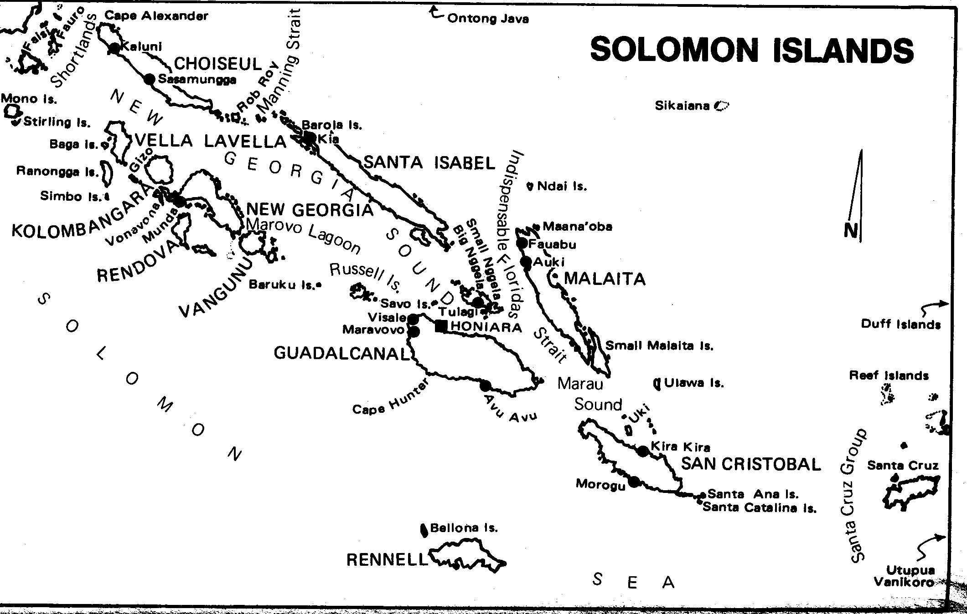
Map from Inder (1978)

The Solomon Islands comprise approximately 1000 separate islands, the majority of which are volcanic. However, there are significant areas of coralline limestone on Rennell, Bellona, the Northern region of Guadacanal, Santa Isabel, Malaita, the Florida Group, Ontong Java, Shortland Islands, Waghena, Sikaiana, the Three sisters and San Cristobal. There has been relatively little investigation of the karst, other than Rennell which is inscribed as a World Heritage Area (see appended statement below).

Identified Caves include:

Guadacanal: Mbao Khol, Mataniko Falls (Vince 1974; Dalrymple 1995a), Poha (Dalrymple 1995b), Nanuololo, Mbetilonga (Illife & Sarbu), Potoruma

Bellona Island

Santa Isabel: Kolokofa, caves near Buala

Floridas Group: Suku Caves and Mbetibula Cave, both on Nggela Pile (Illiffe & Sarbu). Nggela Island: large cave near Egan Bluff
Sandfly Island: Grover (1960) described 11 caves on Sandfly and Small Nggela.

Malaita: Kwakwaru on Basakana Island, Riba Caves near Auki.

San Christobal Island: caves on the Puepue River

Santa Cruz Group-: on Nambalein River, Nondo Is.

Shortland Islands: Cave entrances are visible in the relatively inaccessible karst on the South-western part of the main island. In the North-eastern part of the island, Parker (1972) explored and documented the spectacular Kiahai Cave and two slightly smaller un-named caves that are located on the Kiahai River and another on Nina’ng Creek.
Loun Island. Various bats were also recorded.

Russell Islands: Tomlem Caves (Dalrymple 1995c)

Cave-dwelling Bats

The bats of the Solomons are not well known, but identified cave-dwelling species include:

Rousettus brachyotis
Emballonura dianae, E. nigrescens, E. raffrayana

Aselliscus tricuspidatus
Hipposideros calcaratus, H. diadema, H. cervinus, H. demissus, H. dinops
Miniopterus schreibersi, M. australis, M. propitristis, M. macrocneme

Myotis adversus

Pipistrellus angulatus
Chaerephon solomonis

References

Cole et al, (2000). South Pacific. Lonely Planet Guidebooks, Melbourne. Pp. 352-383.

Dalrymple, Doug (1995a) Matiniko Falls Caves. Speleo Digest 1995: 328. .

Dalrymple, Douglas (1995b) Poha Cave. Speleo Digest 1995: 328

Dalrymple, Doug (1995c) Tomlen Caves. Speleo Digest 1995: 329.

Grover, J.C. (1960) Phosphate Guano in caves of the Floridas Group. British Solomon Islands Geological Review, 2: 90-92.

Iliffe, Thomas M & Sarbu, Serban. (1990) Anchialine caves and cave fauna of the South Pacific NSS News: 48(4): 88-96.

Juberthie, C. & Guinot, D., (1996) Iles Salomon, in Juberthie, C & Decu, V. (eds) 1996. Encyclopaedia Biospelologica: Vol III. Sociètè Internationale de Biospèologie, Moulis, France. Pp. 2115-2119.

Middleton, J. & Waltham, T. (1986) The Underground Atlas. Robert Hale, London.
P. 168.

Parker, F. (1972) Notes on some caves of Shortland Island, Solomon Islands. J. Sydney Speleological Society 16(10): 271-276.

Vince, S. (1974) Caving in the Solomon Islands. Southern Caver 5(4): 10-11.
From UNEP World Conservation Monitoring Centre, Cambridge, U.K.

Protected Areas Programme -Protected Areas Programme
World Heritage Sites

COUNTRY Solomon Islands

NAME East Rennell

IUCN MANAGEMENT CATEGORY : Natural World Heritage Site - Criteria (i), (ii), (iii), (iv)

BIOGEOGRAPHICAL PROVINCE 5.1.13 (Papuan)

GEOGRAPHICAL LOCATION The nominated World Heritage Site is on Rennell Island, which is the southernmost island in the Solomons, and covers portions of the Rennell and Bellona Province. Rennell Island is located approximately 180km to the south of Guadalcanal and to the south-west of San Cristobal. 11°39'-11°43' S, 160°18'-160°20' E.

DATE AND HISTORY OF ESTABLISHMENT There is currently no legislation specifically protecting the natural and cultural features of East Rennell.

AREA East Rennell has an area of 37,000ha and includes Lake Tegano (15,500ha).

LAND TENURE Customary. Lake Tegano is regarded as property common to the people from four lakeside villages.

ALTITUDE From sea level to 1,000m above sea level.

PHYSICAL FEATURES The Solomon Islands is a group of islands of volcanic origin with basement rocks formed along a spreading mid-ocean ridge some time between the late Cretaceous and early Eocene. Around the early Eocene, a convergent plate boundary formed in the vicinity of Rennell and Bellona, to the south of the main Solomon chain. Near the end of the Pleistocene, tectonic movements raised the seabed sufficiently to allow coral building on Bellona, Rennell and Indispensable Reefs. Rennell and Bellona are geologically younger than most of the rest of the Solomon Islands and they have experienced different forces of emergence. Both islands are well away from the crusted plate collision zone and have a very low degree of seismic activity. The structure and geomorphology of Rennell and Bellona indicate that Rennell Ridge on which they are situated is presently situated in a phase of active uplift following a long history of subsidence. The whole Rennell area is thought to have been initially deposited as coralline algal limestone and then dolotomized. This dolomitic reef complex is overlain by younger undolotomized reef limestone. (Wingham, 1997).

Lake Tegano is contained in the central basin which was the old lagoon. It is 29km long and 10km wide and occupies 17.6% of the total area of Rennell Island. It is also the largest body of enclosed water in the insular Pacific. Its central part forms a nearly unbroken plain with a depth rarely exceeding 40m. The hard bottom is covered by several meters of suspended mud. The lake is brackish with the elevated salt concentration being kept by a subterranean duct system that connects it with the sea (Wingham, 1997). There are no streams or rivers on Rennell Island although there are freshwater springs around the lake edge and they emerge in various places from the cliffs at the coast. Sub-surface water flow is likely to be directed along the lower central axis of the island from the highest western and eastward until it enters the lake.

Soils are derived from weathered coral limestone and are present as small scattered pockets. There has been no soil enrichment by volcanic dust or sea-borne river sediment because of the great distance from the larger islands and the direction of the prevailing wind and sea currents. High grade phosphates of alumina and iron oxides are found in Bellona soils and high grade (low silica) bauxite deposits are found on Rennell. Soils have a pH range from 6 at 1cm depth to 8.5 at 6cm (Wingham, 1997).

CLIMATE Rennell and Bellona experience a typical tropical climate characterised by high and rather uniform temperatures (between 22.7°C and 32.2°C) and humidity. Rennell annual rainfall ranges between 3,000mm and 4,000mm. There may be a marked dry period from May to June. This can extend from May to August with a very dry month in July. Southeast trade winds prevail from April to the end of November. The island is also located within the band of known cyclone paths and is subject to cyclones at relatively frequent intervals. The latest major cyclone to hit Rennell was Nina in 1993 which caused extensive damage to the forests and villages (Wingham, 1997).

VEGETATION There are three major vegetation types on Rennell Island: (i) low mature forest of the karst ridge on the island perimeter; (ii) tall forest of the island interior; and (iii) beach flora of the Lake Tekano margins. There are also small patches of mangrove vegetation on the lake margin. The differences in species and structural attributes between the arst ridge and island interior forests are the result of different physical conditions on the exposed island margins and the relatively sheltered island interior where deeper soils occur.

The Solomon Islands constitute a major transition point in the sequence of decreasing floral diversity eastward into the tropical Pacific from Papua New Guinea. The sequence involves a decline in phanerogam genera from c.1,400 in Papua New Guinea to c.260 in both Tonga and Niue. The Solomon group contains almost 650 species of phanerogam with 162, or 25% of the total not occurring on any other island to the east (Wingham, 1997).

To date, no endemic tree species have been found on Rennell Island but ten endemic plants have been recorded so far. The endemic orchid Dendrobium rennellii occurs on the small islands of Lake Tegano. There are also two endemic species of Pandanus (P. lacustris and P. rennellensis).

FAUNA There are 11 species of bats in the area including the Rennell flying-fox Pteropus rennelli which is endemic to the island. Other species present are bare-backed fruit-bat Dobsonia inermis, Pacific flying-fox Pteropus tonganus, spurred horseshoe-bat Hipposideros calcaratus and large Melanesian bent-wing bat Miniopterus propitristis. Some 43 species of breeding land and water birds have been identified. Four species and nine subspecies are endemic to Rennell, and seven are subspecies endemic to Rennell and Bellona. Australian dab-chick Tachybaptushas novaehollandiae and little pied cormorant Phalacrocorax melanoleucus are common at Lake Tegano. Pink-spotted fruit dove Ptilinopus richardsii cyanopterus is endemic to Rennell and Bellona and is found mainly in the canopy but comes lower in second growth. Endemic species include Rennell fantail Rhipidura rennelliana and Rennell shrike-bill Clytorynchus hamlinii (NT).

Lake Tegano is the only known location for the endemic sea krait Laticauda crockeri (VU). The other species of sea snake in the lake is Laticauda colubrina which often tends to come on land when not foraging and hides in rock crevices and holes. There are five species of geckos, four skinks, one monitor lizard (Varanus sp.) and three snakes, all of which are species with widespread distributions and are typical of the region.

No amphibians have been recorded for Rennell Island so far. This is unusual as the rest of the Solomon archipelago has a rich and peculiar frog and toad fauna. This absence is probably explained by the topography and the lack of surface water except for Lake Tegano. Rennell has 27 species of land snails, seven of which are endemic to the island. Coconut crab Birgus latro (DD) and two other species of land hermit crabs (Coenobita sp.) occur on the island. A total 731 insects have been identified from collections made at Rennell and Bellona. Moths (Lepidoptera) have the greatest number of species (246, in total) with 35 species and 25 subspecies exclusive to Rennell and Bellona (Wingham, 1997).

CULTURAL HERITAGE Between 2000 and 1600 BC, people belonging to the Lapita Culture made their appearance. Over a millennium, through long-range canoe voyages, their distinctive pottery was distributed throughout the Pacific at sites from the Bismarck Archipelago in eastern Papua New Guinea to Samoa. Bellona Island was briefly occupied by Lapita people in about 1000 BC. The next settlement occurred on both Rennell and Bellona around 130 BC, with another major occupation in about 1000 AD. The present-day inhabitants say their ancestors landed on Bellona around 26 generations ago in about 1400 AD and came from Uvea, or Wallis in the Wallis and Futuna group (Wingham, 1997).

It is thought that the two islands were officially discovered in 1793 by Captain Boid in the merchant ship Bellona. Traders, whalers and recruiters for the Queensland cane fields called there during the Nineteenth Century, but lack of safe anchorage, the isolation and infertility of the island and shortage of easily obtainable fresh water prevented European settlement and establishment of trading stations (Wingham, 1997).

LOCAL HUMAN POPULATION The population on Rennell has never been large, partly because there are only a few small, scattered areas of soil suitable for gardens and because there are limited fresh water sources. Current population is around 1,500 people and this is declining through emigration to Honiara and the plantations of the Russell Islands. About one third of the population of East Rennell (approximately 500 people) live in four villages surrounding Lake Tegano.

Most villages claim areas of around 57sq.km and hunting areas, which could be shared with other villages, of around 60sq.km. Most of the land cleared for gardens has secondary growth rather than primary forest on it. Traditional garden areas are cultivated for around nine months before being left fallow. The fallow period is around four years when the land is cleared and replanted. Gardens provide a large proportion of the villager's subsistence food and are cash crop as well. The main crops are root vegetables such as kumara, taro and pana. Slippery cabbage and paw-paw are also grown. Most villages produce coconut for sale.

Up to thirteen species of birds are taken regularly for food. All villages harvest marine animals including clams, turtles and sharks. A smaller number of villages take crayfish, dolphin and octopus and a species of seaweed. In East Rennell fish is a regular part of the diet but it is mostly Tilapia mozambica which is harvested from the lake. The government introduced this species around 1957 as an additional protein source for the villagers.

There has been no commercial logging on Rennell but local people have been using portable mills to produce timber for local use. Most villages have an average of two chainsaws. There are no fixed sawmills and three villages make charcoal. The forest is a storehouse for the villages providing timber, poles and posts, ropes and canes, firewood, food, medicine, bark for tapa cloth, canoe wood, carving wood and materials for tools, fishing and crafts.

Orchids, butterflies and small animals are occasionally taken from the forest and sold. More commonly, coconut crabs are harvested as well as coral and shells. There are no reports of live birds being sold.

Rennell Island is unusual in the Solomon group as it does not have any river or stream. The brackish water of Lake Tegano is used for bathing, laundry and cooking. Drinking water traditionally came from caves, springs and rock pools. All villages now have some rainwater tanks but these often run out in dry season (Wingham, 1997).

VISITORS AND VISITOR FACILITIES There are opportunities for bird-watchers, botanists, photographers and other people who like to visit isolated areas or view World War II relics. The outstanding natural beauty of the lake and the island, snorkelling, bush walks, cultural activities and trips by canoe are only a few of the attractions available.

A road linking Lavagu and Lake Tegano was completed in 1995. Small planes fly to Rennell three times a week and can take 18 passengers. A cargo ship that also takes passengers sails approximately once a month. Otherwise, there are no facilities for visitors on the island (Wingham, 1997).

SCIENTIFIC RESEARCH AND FACILITIES Rennell has been studied as part of eight major scientific expeditions. A comprehensive list of scientific papers regarding the fauna and flora of the island is provided in Wingham (1997). There are no scientific facilities on the island.

CONSERVATION VALUE The fauna of the Solomon Islands is of considerable international importance. With the exception of Papua New Guinea, the Solomon Islands have a greater diversity of animal species and higher level of endemism than any other Pacific island nation. Within the Solomon Islands, Rennell has the highest occurrence of endemism for an island of its size. Rennell is famous for having developed many unique species and races of birds because of its isolation. East Rennell is important because it includes all the habitats found on Rennell and contains a viable representation in natural conditions of most endemic bird species (Wingham, 1997).

Rennell is the world's largest raised coral atoll. Throughout the Pacific there are about 25 such atolls, most of which have been significantly modified by human activity (except for Henderson Island World Heritage site which is one-tenth the size of Rennell but is more pristine). Lake Tegano is the largest lake in the insular pacific and contains a number of endemic species (although not as many as the lakes in Palau). The forests of the nominated area are mostly undisturbed by humans and display a number of adaptations to the effects of frequent cyclonic storms. For its size, Rennell Island has a high number of endemic species, particularly birds. Along with 29 other Islands in the Pacific, Rennell is listed as an endemic bird area by Birdlife International (though it is ranked third level in terms of priorities). Within the pacific, most oceanic islands have been much modified by human activity. On Rennell, these impacts have been relatively light and invasive predators such as rats and alien land snails which have decimated the faunas of other islands are absent.

In conclusion, ER has a number of marine, coastal and forest values that are better displayed in other Pacific locations. The fact, however, that ER combines them in one place and in a relatively undisturbed state makes the island a special place in the Papuan Biogeographical Province.

CONSERVATION MANAGEMENT The people of East Rennell have helped to prepare a draft resource management plan with input from the Tegano Management Conservation Committee, the provincial members, the Council of Chiefs and the Paramount Chief. This is in preparation and will be circulated and revised to form the East Rennell Resource Management Plan. The local peoples' understanding of environmental matters and desire to generate income through ecotourism are all factors that work together to give protection to the area. The Ministry of Forests, Environment and Conservation of the Solomon Islands will be responsible for reviewing the Resource Management Plan (Wingham, 1997).

MANAGEMENT CONSTRAINTS Rennell Island is isolated geographically from Guadalcanal. It is sparsely populated and is characterised by pristine rain forest. Very few areas have been modified by logging and shifting cultivation. With the extension of the road in 1995 from Lavagu to the lake end, timber trees were removed from both sides of the road. Much of this timber has been used for rebuilding houses after cyclone Nina.

Following cyclone Nina many mature trees were blown down creating gaps in the forest canopy. This has led to increased growth of the vine Meremia peltata which appears to be degrading the forest.

Terrestrial mammals have been introduced to the island and some have become feral, e.g. pigs and goats. They do not appear to be in large numbers. Some households have cats and education is needed so that they do not become a problem (Wingham, 1997).

STAFF No information

BUDGET No information

LOCAL ADDRESS Director of East Rennell, Tourism Division, Department of
Commerce, Employment and Tourism, P.O.Box G26, Honiara, Solomon Islands;
Paramount Chief of East Rennell, C/o Tigoa, West Rennell, Rennell and
Bellona Province, Tel. 26852, E-mail:commerce@commerce.gov.sb. There is
also a website http://www.commerce.gov.sb/Tourism/RennellandBellona.htm.

REFERENCES

Some of the principle references listed in Wingham (1997) included as follows:

Cogger, H., Heatwole, H., Ishikawa, Y., McCoy, M., Tamiya, N. and Teruuchi, T. (1987). The status and natural history of the Rennell Island sea krait, Laticauda crockeri (Serpentes: Laticauda). Journal of Herpetology 21: 255-266.

Diamond, J.M. (1984). The avifauna of Rennell and Bellona Islands. In Wolff, T. (ed.) The Natural History of Rennel Island, British Solomon Islands. University of Copenhagen, Danish Science Press. Pp. 127-168.

Flannery, T.F. (1995). Mammals of the south-west Pacific and Moluccan Islands. Imago Productions. Singapore.

Grover, J.C. (1960). The geology of Rennell and Bellona Atolls: the great uplifted atolls on the edge of the Coral Sea. In Wolff, T. (ed.) The Natural History of Rennell Island, British Solomon Islands. University of Copenhagen, Danish Science Press. Pp. 103-119.

Pegler, J.M. (1996). A bird study at Rennell Island, Solomon Islands. Unpublished.

Wingham, E.J. (1997). Nomination of East Rennell, Solomon Islands for
inclusion in the World Heritage List - Natural sites. New Zealand Official
Development Assistance Programme, Ministry of Foreign Affairs and Trade.
47 pp.

DATE February 2000

Tahiti & French Polynesia

Most islands are volcanic although there are also some low atolls.

Tahiti has some half dozen lava tubes or other volcanic caves. The best known is the Grotte Maraa, which is an attractive site with a large pool filling most of the cave. It is populated by shrimps, but they are surface-dwelling species.

Varnedoe (1973) explored the Marquesas Islands, but found neither lava tubes nor karst caves. However, he recorded 111 sea caves on the five islands. Most were inaccessible but he travelled around each of the five islands by boat and mapped the profiles of all cave entrances.

Varnedoe, B. 1973. The Marquesan Cave Survey. Huntsville Grotto Newsletter 14(1): 7-11.
(Reprinted in SpeleoDigest 1973 National Speleological Society, Huntsville, Alabama 1980, pp.128-130.)

Tonga

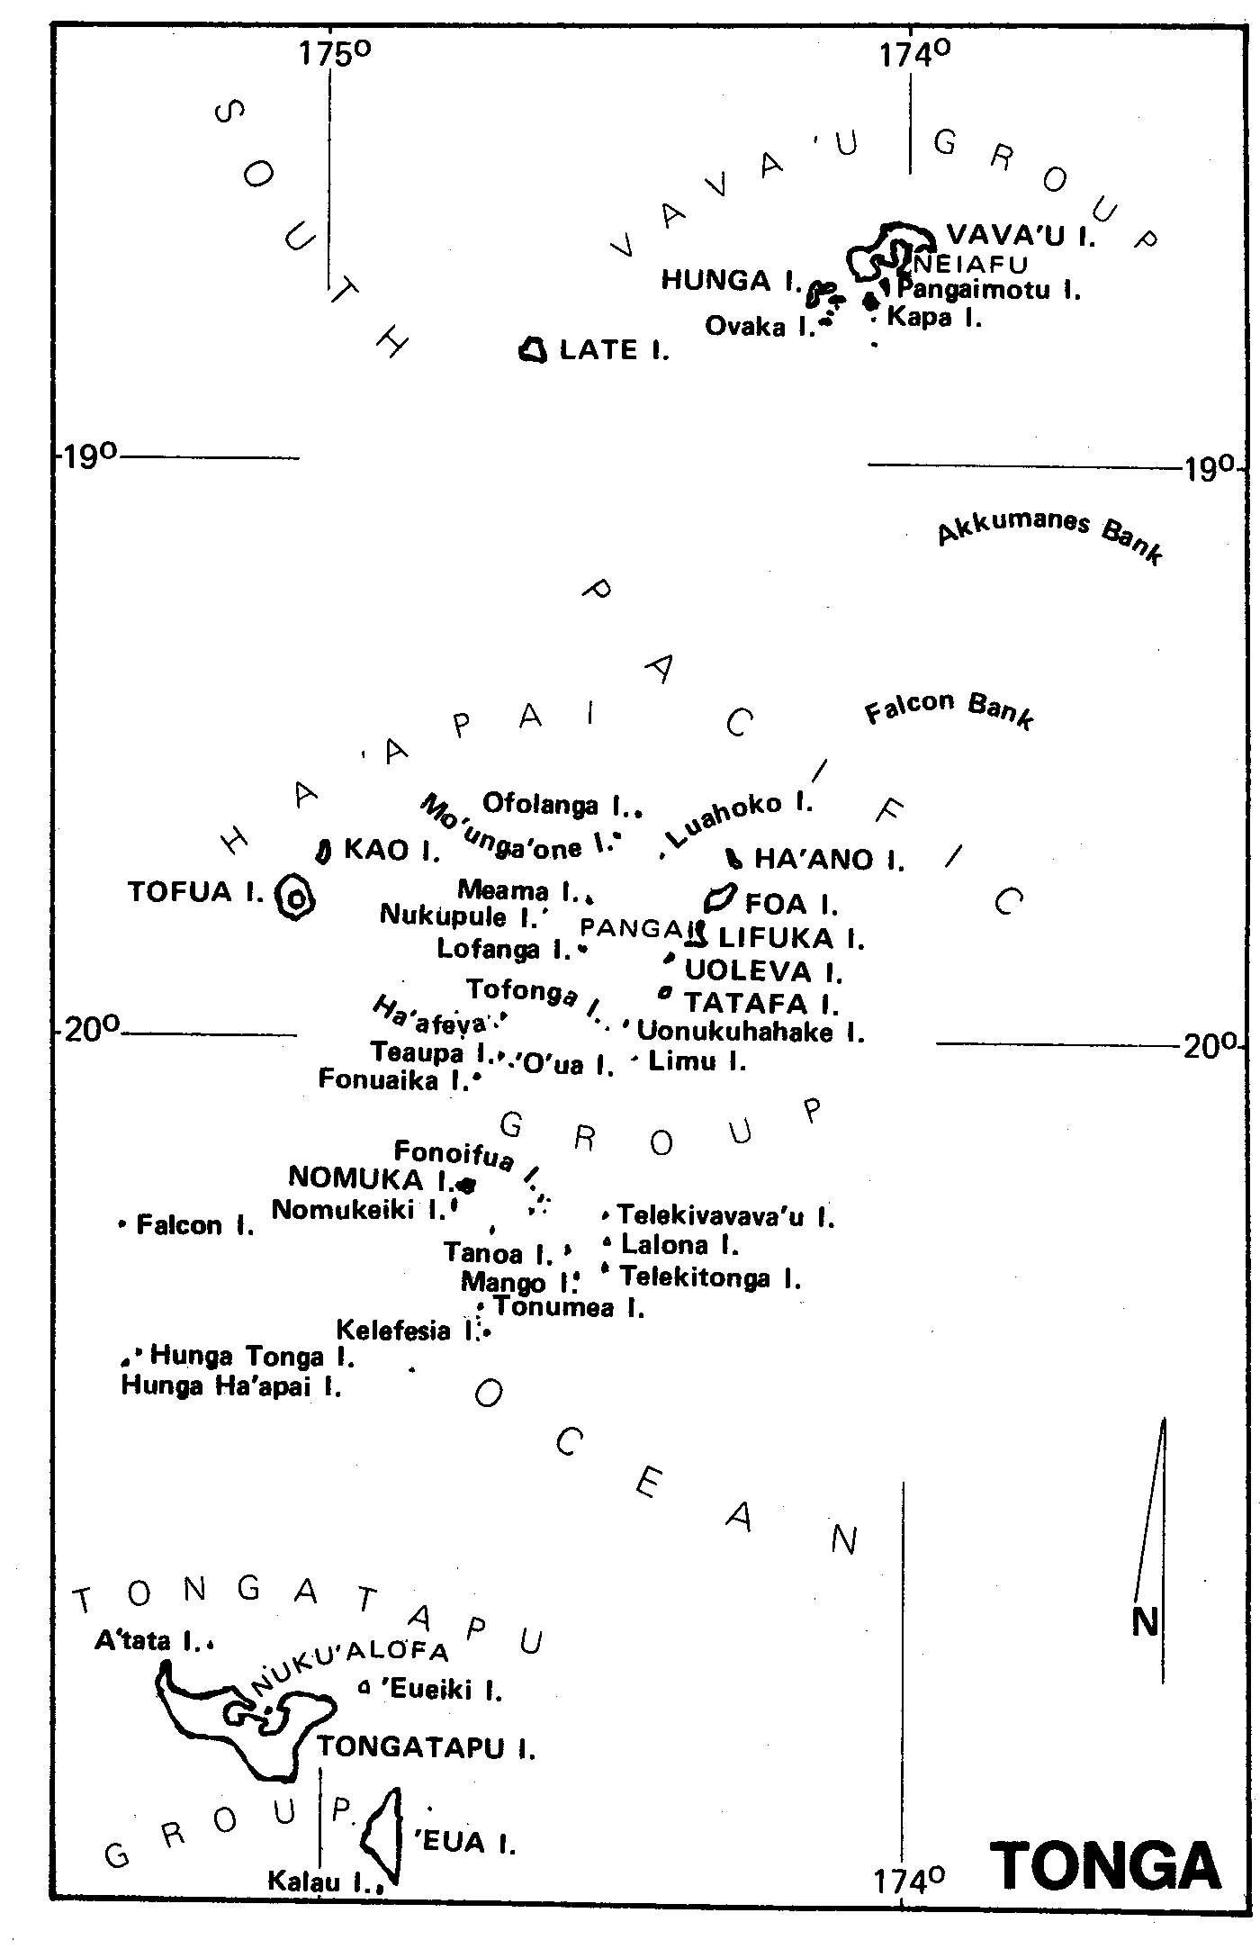
Map from Inder (1978)
Overview

The Tongan archipelago is conveniently divided into three island groups, Vava’u in the north, Ha’apai in the middle and the Tongatapu Group in the south. Limestone caves are known in all three groups but only those in the Tongatapu Group are of any size. Within the island groups there is also a broad west-east division whereby the oldest and geologically most complex islands occur in the east and the youngest in the west.

In the Tongatapu Group the easternmost island, ’Eua, has a complex geological history stretching back at least to early Eocene times. Since this time the island's basement of igneous rocks has been submerged and uplifted several times, and a sequence of carbonate rocks of Eocene to Recent age now encircles the basement core. To the west, Tongatapu itself is at a stage analogous to that reached by ’Eua at the end of the Miocene or in the early Pliocene. Its basement is currently buried by younger rocks and lies well below sea level. A relatively subdued relief of Pleistocene rocks remains. There is no example of a still younger island westward within the Tongatapu Group, but only a short distance to the north-west, the gradation is completed by volcanic islands, both active and quiescent, of the Ha’apai Group. These islands represent the stage reached by ’Eua in late Eocene times. They are essentially volcanic piles, but carbonate build-ups around them are assumed to be analogous to Eocene carbonates that hold most of the caves of the ’Euan uplands. The juvenile carbonates that surround volcanic islands such as Falcon, Kao, Tofua and the recently active Metis Shoal await study by ‘diving geologists’. However, a number of caves have been explored on Tongatapu and ’Eua.

There are nine caves >50 m in length currently known on Tongatapu, one of which (Ana Hulu) used to be a show cave although the cables and lamp fittings have been removed. The caves represent sections on at least three ‘levels’ that are assumed to have developed relative to separate sea-level still-stands. Though isolated fragments preserved within patch reef deposits in the interior of the island lie at a similar level to the more extensive coastal caves (c.25m above sea level) it is uncertain if they are of the same age, since the island is known to have formed and been uplifted unevenly. Of the coastal caves, those at the highest levels have been extensively modified by breakdown and those at the lowest known level have passages at or below sea level. By comparison with areas such as the Bahamas (Mylroie et al., 1995) or the Trobriand Islands (Ollier, 1975) it would be expected that deeper dissolutional development underlies the lowest currently known passages, at the base of the freshwater lens. A lack of known resurgences on the island implies that the dispersion zone intersects the rock surface below sea level. In this context it is tempting to wonder whether extensive ‘terraces’ of calcite that are being deposited at sea level along part of the south coast of the island owe their origin to submarine resurgence and degassing of supersaturated water from beneath the island.

It may be deduced that processes similar to those currently active on Tongatapu have been active throughout the history of ’Eua island. Whereas the recorded history of Tongatapu is probably one of net emergence (with minor climatic oscillation) from the sea, it is likely that the whole of proto-’Eua was re-submerged due to tectonic effects at least twice since Eocene times.

Over 35 caves have been explored on ‘Eua, most of them being relatively young, vertically extensive doline drains with depths commonly exceeding 100m and including one spectacular 70m shaft. However, remnant sections of sub-horizontal passages preserved in some of the caves at levels now c.200m above sea level were probably conceived when their host rocks were close to sea level during late Eocene or Oligocene times. Since then they have been preserved as the island has oscillated between uplift and subsidence, and during this activity the effects of tectonism have affected the pre-existing passages. Particularly convincing are high-level fragments such as the magnificent Palangi Chamber in First Cave. This remnant of a huge old passage is preserved between two faults and bears no genetic relationship to a younger, fissure-guided doline drain (First Cave itself) that has fortuitously opened access to the chamber by utilising one of its limiting faults. To the south, a similar situation exists where the horizontal drain of Ana Maui is truncated by a major strike slip fault, possibly continuing (but displaced laterally by c.150m) as a fault-bounded chamber in Ana Sikota. Similar isolated sub-horizontal fragments are preserved at various lower levels within the main Eocene carbonate mass, but also within a variety of younger carbonates.

In the mid 1980’s many of the caves contained large populations of cave swifts and of bats and their guano supported a rich troglobitic invertebrate fauna. Aquatic invertebrates were also collected and sent to Dr Peter Maddison at the DSIR, Auckland but unfortunately no results were ever received. Gecko (Cyrtodactylus pelagicus) were collected from 2 caves on ‘Eua but not observed on the surface. Cave crabs were also observed, possibly preying on bats.

The effect of freshwater-lens marginal mixture dissolution has been, and continues to be, crucial to the establishment of underground conduits within the geologically young, relatively porous limestones on Tongatapu Island in the Tongan archipelago. So far as it is possible to reconstruct the earliest speleogenetic events in the older preserved sequences on the nearby ’Eua Island, it appears that the processes that acted upon young reefal and back-reef carbonates during the Eocene were effectively the same as the processes that have acted on subsequent deposits and are still active today.

In the south-east of Tongatapu island are a number of caves at levels at or close to 25m above sea level that have been described by Lowe & Gunn (1986) and Iliffe & Sarbu (1990). Caves such as Oholei Cave, Easter Cave and Fatumu Cave exhibit a mutually similar morphology and trend approximately perpendicular to the present coast. They generally include a relatively deep mid-section that in places includes pools of fresh water where the top of the freshwater lens is encountered. At the ends of these caves, adjacent to the coast and inland, inclined passages join the deep mid sections to the surface. Easter Cave has open entrances at both its seaward and landward ends; Fatumu Cave only at its seaward end and Oholei Cave only at its landward end, but the lack of entrances in these latter two cases reflects blockages rather than the absence of passages. These caves, and possibly others at this approximate altitude elsewhere on the island, probably had a similar origin to caves closer to sea level. However, they appear to have been modified to a lesser or greater degree by breakdown or foundering, in a manner similar to that discussed by Jennings (1968) on the basis of unpublished ideas presented by Hill (1957). Caves such as Ana Hulu and Fua’amotu (Lowe & Gunn, 1986), also on the southeastern coast, are entered close to sea level. Their morphology is similar to that of the higher-level caves. Many passage sections suggest foundering into pre-existing sub-horizontal voids, but in these caves sections of uncollapsed passage survive. The caves include flooded sections that are assumed to be connected to the sea, though diving to depths of at least 20m has revealed no open routes. Another cave, with its entrance altitude between the two sets discussed above, the Haveluliku Cave (Iliffe & Sarbu, 1990), was extended by diving beyond a flooded sub-horizontal section at and below sea level, to regain upward trending passage. The overall morphology is similar to that displayed by the higher level caves.

Much of the cave passage explored to date on ’Eua falls into the “Inakebu” type of Ollier (1975). These comprise vertical and sub-vertical fissures guided by faults and tension gashes, which may locally be linked by short sections of sub-horizontal dissolutional passage, assumed to have formed within a limited number of favourable horizons. At their lowest levels most caves meet sub-horizontal passages analogous to Ollier’s (1975) “Bhabwatu” (upper lens marginal or water table) and/or “Tumwalau” (uplifted phreatic, but probably best considered as relict lower lens marginal) cave types. Cave fragments visible in cliff faces on the east coast of ’Eua are not true sea caves and owe their present form to erosional truncation processes identical to those discussed by Ollier in the Trobriands.

[The above account is by John Gunn, and appeared initially in for the First Draft Version of the Atlas of Karst and Karst Conservation: Vol. 1 Asian-Pacific Region. The most detailed and comprehensive further published descriptions are those by Lowe & Gunn 1986 and Lowe 1989. These reports described 48 caves on Eua Island and 8 on Tongatapu. ]

It appears that apart from several anchialine species of crustacea, the invertebrate fauna of the caves is not cave-adapted (Illiffe & Sarbu 1996). There is only one species of cave-dwelling bat (Emballonura semicaudata) and a species of swiftlet (Collocalia sp.) reported from the caves.

The Blowholes, which occur mainly along the South Coast of Tongatapu must also be recognised here. The fountains of water that are ejected on a windy day may rise as high as 30m. (Cole et al, 2000: 501). Various other caves are also briefly described in Inder (1978), and Pawson (1974) simply lists 22 caves by name.

The report by Williams et al (1986) includes a detailed description of the Anahulu cave and general comments on Tongan caves. However much of it is focussed upon re-development of the cave as a commercial attraction. Little further action has been taken on tourism in this cave.

Millar & Smith (2002) examined potential tourism sites on the Island of Eua, and identified three sites with high tourism value. They examined 16 caves, and also re-visited Anahulu.

References

Cole et al, (2000). South Pacific. Lonely Planet Guidebooks, Melbourne, p. 501

Gunn, J. & Lowe, David (1989) Caves on the Tongan Islands of Tongatapu and ´Eua. Proceed. Intern. Congr. Speleol., Budapest 1989, Vol. 1: 204-205.

Gunn, J. & Lowe, D.J. (2000) Speleogenesis on tectonically active carbonate islands. In: Klimchouk, A., Ford, D., Palmer, A. & Dreybrodt, W. (Eds.) Speleogenesis: evolution of karst aquifers. National Speleological Society, 238-243.

Iliffe, T. M. & Sarbu, S. (1990) Anchialine caves and cave fauna of the South Pacific. National Speleological Society News, April 1990. 88-96.

Iliffe, T. M. & Sarbu, S. (1996) Tonga in Juberthie, C & Decu, V. (eds) (1996). Encyclopaedia Biospelologica: Vol III. Sociètè Internationale de Biospèologie, Moulis, France, pp. 2191-2194..

Inder, S. (ed.) (1978) Pacific Islands Yearbook. Pacific Publications, Sydney, pp. 413-416.

Jennings, J. N., (1968) Syngenetic karst in Australia. In: Williams, P. W. & Jennings, J. N., eds: Contributions to the study of karst, Australian National University: Research School of Pacific Studies. Publication G5.

Lowe, D. J., (1989) Tonga '87 - the Report of the 1987 speleological expedition to ’Eua Island, Kingdom of Tonga. 28+ii pp, 18 figures, photographs. (Private publication.)

Lowe, D. J. & Gunn, J., (1986) Caves and limestones of the islands of Tongatapu and ’Eua, Kingdom of Tonga. Cave Science: Transactions of the British Cave Research Association 13 (3). 105-130.

Lowe, D.J.& Gunn, J., (1998) Cave development in Tonga: Is the present the key to the past ? Abstracts of the 1998 BCRA Science Symposium, University of Keele on 7th March, 1998; in: Cave and Karst Science, vol. 25 (1) April 1998: 37-40.

Millar, Ian & Smith, D. (2002) Caves and Tourism, ‘Eua, Kingdom of Tonga. 22pp.

Mylroie, J. E., Carew, J. L. & Vacher, H. L., (1995) Karst development in the Bahamas and Bermuda. In: Curran, H. A. & White, B., eds.: Terrestrial and Shallow Marine Geology of the Bahamas and Bermuda: Geological Society of America Special Paper 300. 251-267.

Ollier, C. D., (1975) Coral island geomorphology - the Trobriand Islands. Zeitschrift fur Geomorphologie 19 (2). 164-190.

Pawson, K. (1974) Tonga Islands caves. Canadian Caver, 6(1): 26-27. (Note: this list is obscured by being published as an appendix to a paper on the Caribbean.)

Smith, D., (2004) Caves of Eua, Kingdom of Tonga. ACKMA Journal, 54: 4-8.

Spenneman, D. (1997) A Holocene sea-level history for Tongatapu, Kingdom of Tonga, in Sherwood, A.M. et al (Eds.) Coastal and Environmental Geoscience Studies of the Southwest Pacific Islands. South Pacific Applied Geoscience Commission Technical Bulletin 9: 115-153.

Spenneman, D. & Head, M.J. (1998) Tongan pottery chronology, ¹⁴C dates and the hardwater effect. Quaterary Geochronmology, 17:1047-1056.

Taylor, F. W. & Bloom, A. L. 1977. Coral reefs on tectonic blocks. Tonga island arc. Proceedings of the Third International Coral Reef Symposium, Rosenstiel School of Marine and Atmospheric Science, University of Miami. 275-281.

Williams, D., Wilde, K. & Worthy, T. (1989) Anahulu Cave and Environs, Tongatapu, Kingdom of Tonga: Recommendations for development. Australasian Cave and Karst Management Association, New Zealand.

Vanuatu

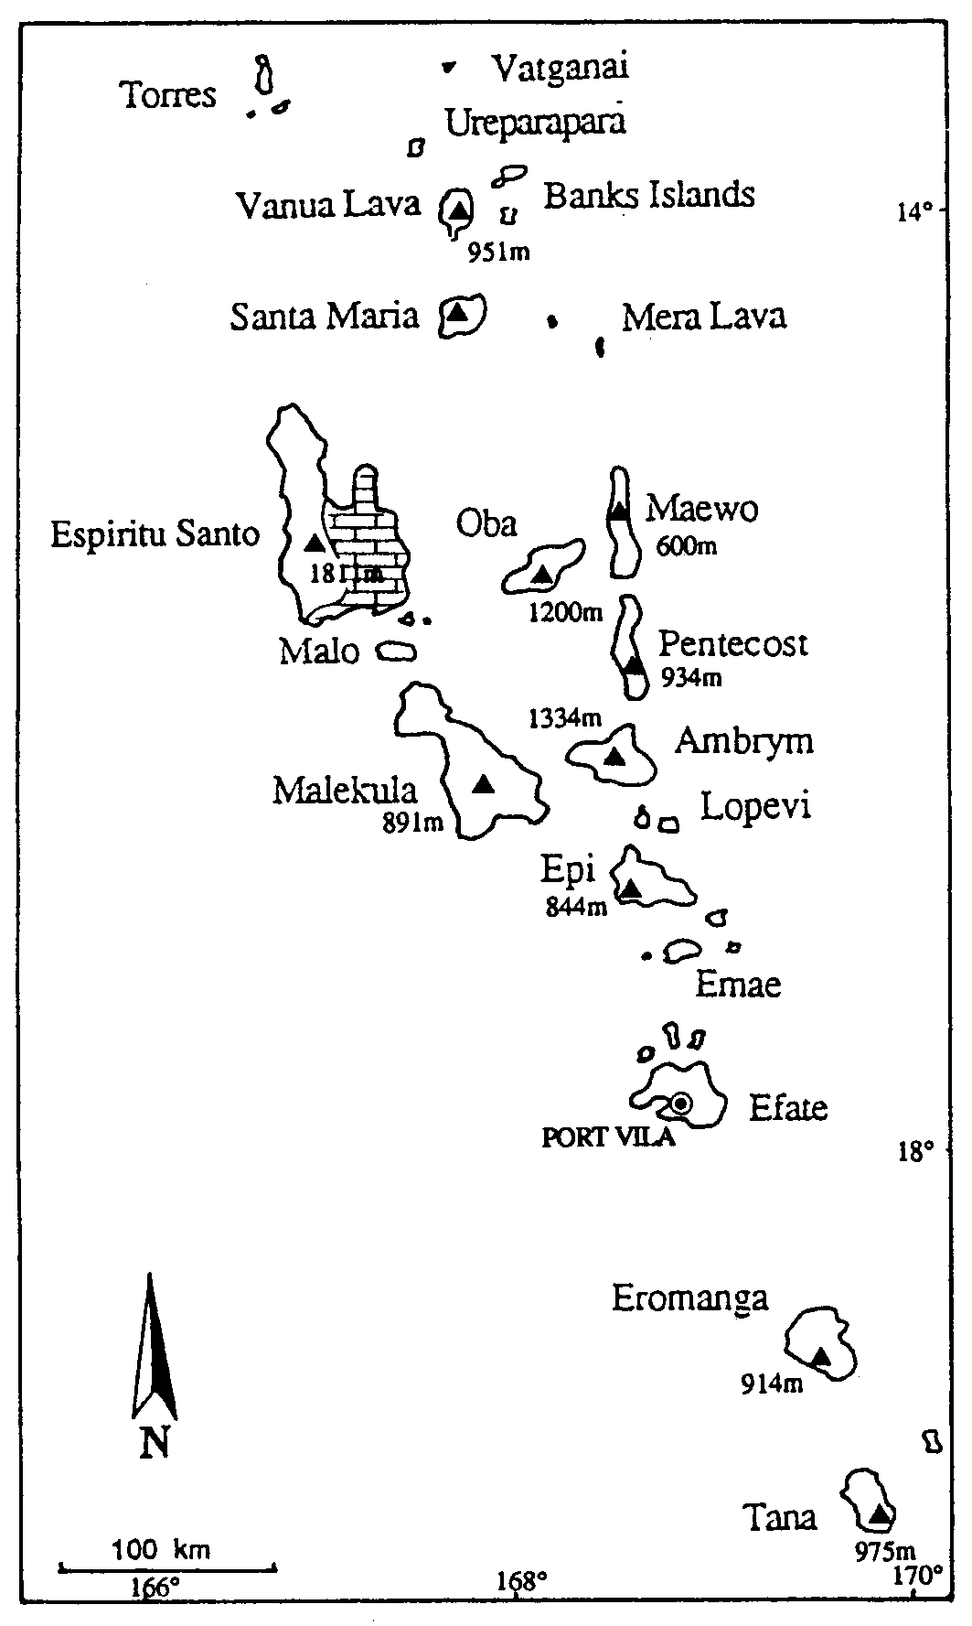
Map from Juberthie (1996)

Overview

Vanuatu is a series of islands, most being of volcanic origin, and some volcanoes remain active. However, there are a number of areas of limestone, but none have been fully investigated or documented. In general, the limestones form a series of terraces, each marking successive still-stands of sea level; caves often occur at the interface between terraces.

Harris (2005) has established a framework for on-going documentation of caves and related karst features. It is to be hoped that this will be utilised by future investigators.
He notes that other divers have explored a number of caves, but there is little systematic documentation of their finds. His own reports of diving in Clearwater Cave and the Sarakata River Cave appear on his Web-site. Some further information is available on the Trimix divers Web Site.

Espiritu Santo

The largest limestone area is on and associated with Espiritu Santo. A large part of the North-Eastern part of the island is limestone, and includes the Loru Conservation area and the Hog Harbour area (Baker & Bird 1936). The Vatthe Conservation Area is also located on karst with a spectacular 400m. scarp. Several bat caves exist on Aore Island (current author visited in 1965) at the foot of the first terrace along with one cave used by Collocalia swiftlets. Harris (2005) provides brief descriptions of some 35 caves including the Sarakata River that emerges from a long and complex series of cave passages. Caves are also reported on Araki Island and on Segond Channel. The ‘Blue Holes’ or ‘Blue Springs’ of Santo are also of karstic origin, but have not been properly investigated.

Other Occurrences

A World Heritage Tentative listing, prepared by Shing and Wilson (2004) includes the sacred precinct of Northwest Malekula. Two of the most important sacred sites are the ‘spirit’ caves, Yalo and Apialo. Both have been recognised as sacred and as a site of pilgrimage over the last 3,000 years, continuing to the present day. Both are richly decorated with paintings and engravings.

Another site in this listing is the Vatthe Conservation area on the Northern coast of Espiritu Santo. It includes three caves which are used as roosting sites by bats (Aselliscus tricuspidatus, Hipposideros cervinus and Miniopterus australis.

The most accessible cave is the Falefa bat cave at Siviri on Efate Island (also visited by the current author). Harris (2005) describes a further six caves on Efate, including Clearwater Cave. .

Other occurrences are on Malo, Maewo, The Northen end of Pentecost and Erromanga . Harris suggests caves will probably occur on most islands, and notes that many others were rumoured on both Efate and Espiritu Santo.

Cave-dwelling Bats include:

Notopteris macdonaldi:
Hipposideros cervius: Hog Harbour, Falefa Cave
Ascelliscus tricuspidatus:
Myotis adversus:
Miniopterus australis: Hog Harbour, Falefa Cave
Miniopterus propitristis: Hog Harbour – identified as M. schreibersii by Baker & Bird (1936)
Miniopterus macrocneme: Hog Harbour
Chaerephon bregullae: Flannery (1995) records this species from:
Nanumbu Cave, Espiritu Santo (also recorded as Wonban Tori)
Tan Lesingo Cave, Malo

References

Baker, J. and Bird, T.F. (1936) The seasons in a tropical rain-forest (New Hebrides) 4: Insectivorous Bats (Vespertilionidae and Rhinolophidae) J. Linnean Society, Zoology,
40 (269): 143-161.

Flannery, T. (1995) Mammals of the South-West Pacific and Moluccan Islands. Cornell University Press, New York.

Geze, B., (1963) Observations Spéléologiques dans le Pacifique. Spelunca Mem. 3: 103-114.

Harris, R. (2005) Caving and Cave Diving in Vanuatu, CEGSA News, 50(2): 36-44.
See also www.divedoc.net

Juberthie, C. (1996) Vanuatu, in Juberthie, C & Decu, V. (eds) (1996). Encyclopaedia Biospelologica: Vol III. Sociètè Internationale de Biospèologie, Moulis, France, pp. 2147-2148.

Trimix Divers. See www.trimixdivers.com/index.htm

